 

|  |
| --- |
|  |

|  |
| --- |
| *Software Engineering-1*  *Software Design Document*  *For*  *Web-Service to code project* |
| *Dr. Mohammad El Ramly*  *TA. Desoky Abdelqawy*  *Leader: Mariam Fouad Saeed*  *e-mail:*  *mariam-_-fouad@hotmail.com* |
| *Date:*  *November 8, 2014* |

Contents

Team 2

Document Purpose and Audience 2

System Models 2

System Decomposition 2

Class diagrams 3

Sequence diagrams 4

Class - Sequence Usage 4

User Interface Design 7

Ownership Report 8

# Team

|  |  |  |  |
| --- | --- | --- | --- |
| ID | Name | Email | Mobile |
| 20120493 | **Mariam Fouad Saeed** | **mariam-_-fouad@hotmail.com** | **01115658976** |
| 20120195 | **Salwa Ahmed Mahmoud** | **gaza_3ashekah@yahoo.com** | **01158379344** |
| 20120446 | **Huda Mohammad Abdel Raouf** | **huda.fci@gmail.com** | **01286204342** |
| 20120456 | **Yasmin Abdel Latif Mohammad** | **yasmeen.kloub@gmail.com** | **01275511358** |

# Document Purpose and Audience

* **The purpose from this document is to design the system, view the relationships in it, and show the initial look of the project after it finished.**
* **In this phase, the overall view of the system must be clear.**
* **This document is used as a guide and reference to the next steps in the project.**
* **This document is intended for the project manager and team member to keep track of the project.**

# System Models

## System Decomposition

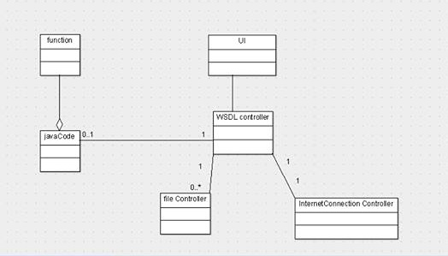

## Class diagrams

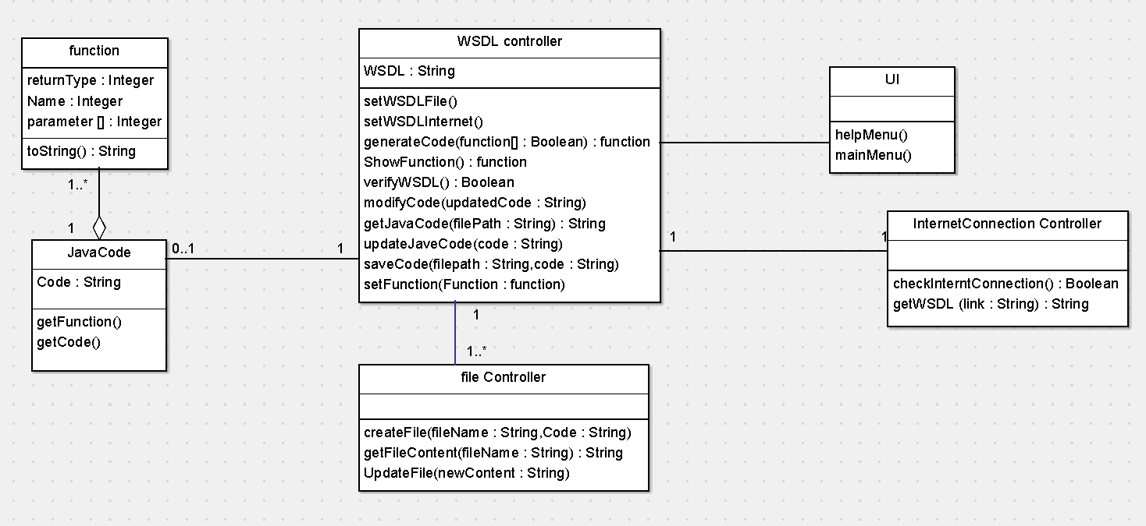

|  |  |  |  |
| --- | --- | --- | --- |
| **Class ID** | **Class Name** | **Subsystem ID** | **Description** |
| 001 | UI |  | Specified for the whole software UI |
| 002 | WSDLController |  | it controls the WSDL summation , WSDL to code generation and modifying the code , the basic function needed for the project |
| 003 | function |  | contain the basic elements that identify any function |
| 004 | fileController |  | a class specified to deal with file in the device and any method needed in them |
| 005 | InternetConnectionController |  | a class specified to check the device connection and get the WSDL from the Internet |
| 006 | javaCode |  | contain the generated code methods and the code it self |

## Sequence diagrams

### Submit WSDL

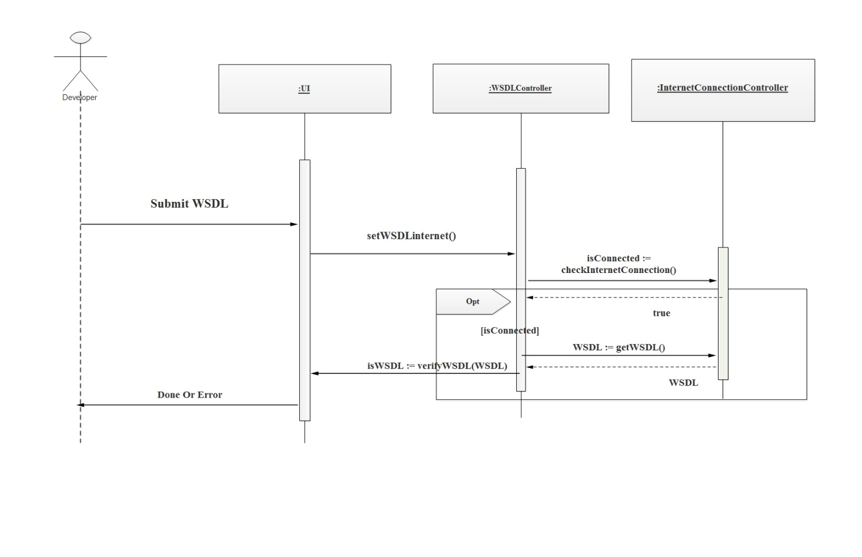

### Class - Sequence Usage

|  |  |  |
| --- | --- | --- |
| **Class Name** | **Sequence Diagrams** | **Overall used methods** |
| UI | 002 | SetWSDLinternet, verifyWSDL |
| WSDLController | 001,005 | getWSDL, verifyWSDL, setWSDLinternet, checkInternetConnection |
| InternetConnectionController | 002 | getWSDL, checkInternetConnection |

### Generate Java Code

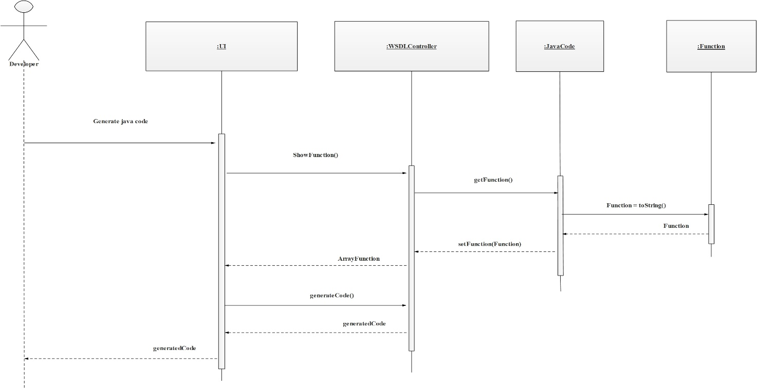

### Class - Sequence Usage

|  |  |  |
| --- | --- | --- |
| **Class Name** | **Sequence Diagrams** | **Overall used methods** |
| UI | 002 | ShowFunction,generateCode |
| WSDLController | 001,006 | ShowFunction,generateCode, getFunction, setFunction |
| javaCode | 002,003 | getFunction, setFunction, toString |
| function | 006 | toString |

### Modify Code

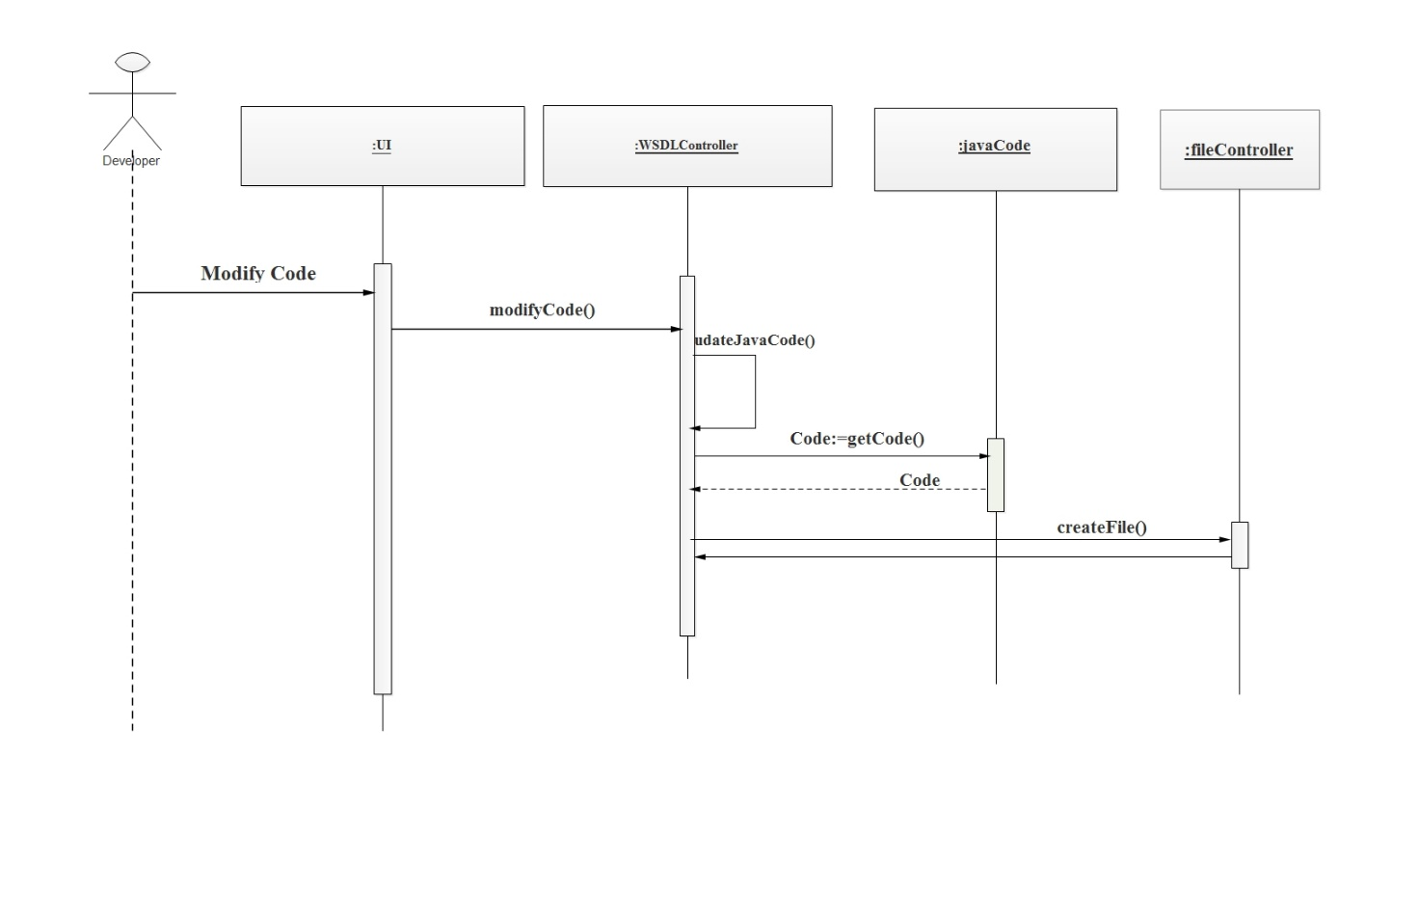

### Class - Sequence Usage

|  |  |  |
| --- | --- | --- |
| **Class Name** | **Sequence Diagrams** | **Overall used methods** |
| UI | 003,005,006 | SubmitWSDL,getWSDL,verifyWSDL |
| WSDLController | 004,006 | GetWSDL,generateCode,getFilePath |
| javaCode | 004,005 | getJavaCode |
| fileController |  |  |

## User Interface Design

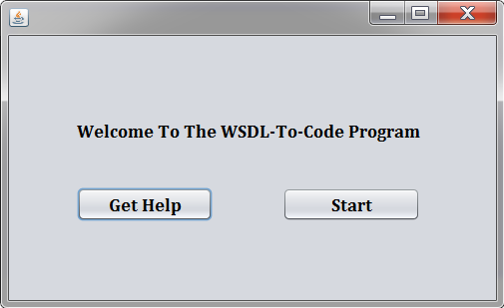

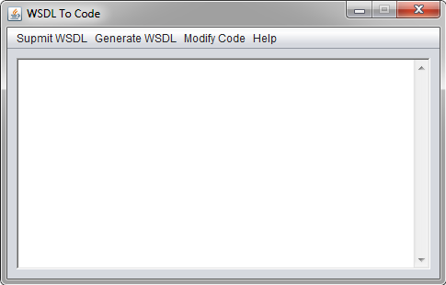

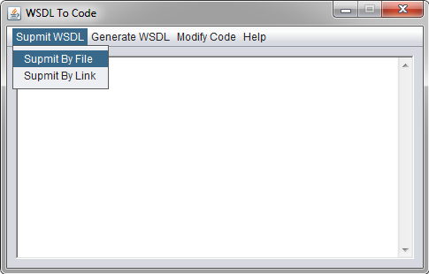 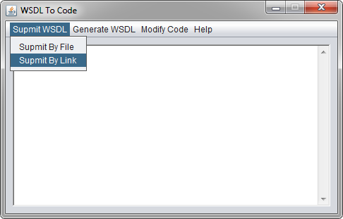 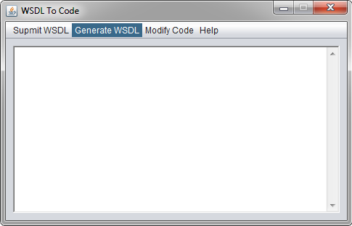

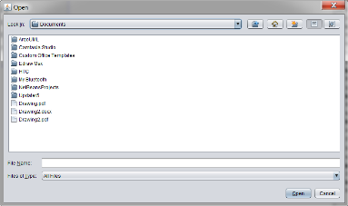 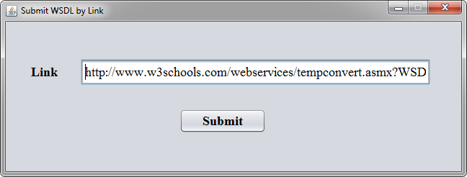 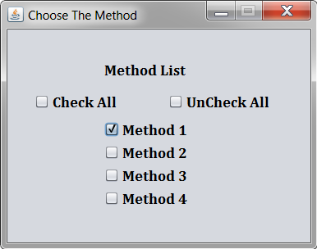

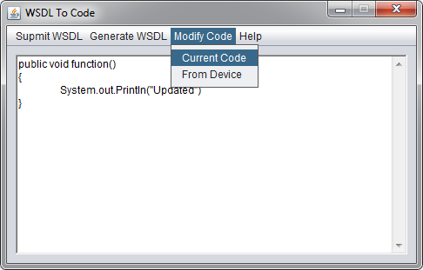 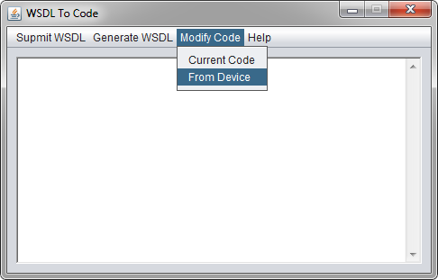 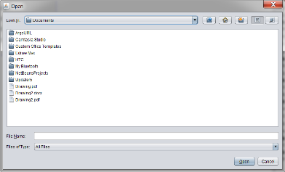

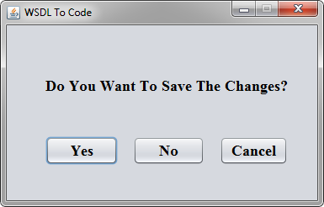

# Ownership Report

|  |  |
| --- | --- |
| Item | Owners |
| System Decomposition , Class diagrams | **Mariam Fouad** |
| Sequence diagrams , Class - Sequence Usage | **Yasmeen Abdel Latif** |
| System Models | **Salwa Ahmed** |
| Document Purpose and Audience , User Interface Design | **Huda Mohammed** |